13. Напиши по 2 тести для свого сайту з валідними і невалідними даними, використовуючи

* 1. Еквівалентне розділення - [відео](https://youtu.be/TiclktlAk6o)
  2. Граничні значення - [відео](https://youtu.be/4bJky_qpzNM)
  3. Попарне тестування - [відео](https://youtu.be/Wh5B6563MgA)
  4. Вгадування помилок — [відео](https://youtu.be/aAlLAWanHFs)

Еквівалентне розділення

**1.Summary:** Filling out the product order form with valid data

**Preconditions**

1. The https://parfumcity.com.ua/ua website is opened.

2. The user is not registered on this website.

3. Add any product to the cart

|  |  |  |
| --- | --- | --- |
|  | **Steps** | **Expected result** |
| 1 | Click on the basket icon. | The shopping cart іs opened. |
| 2 | Enter “Марія Петрова” valid data in the “Ім'я, прізвище” field in the product order form. | The entered data are accepted, field is  highlighted in green color. |
| 3 | Enter “+380977777777” valid data in the “Телефон“ field in the product order form. | The entered data are accepted, field is  highlighted in green color. |
| 4 | Enter valid data in the “Промокод“ field in the product order form. | The entered data are accepted, field is  highlighted in green color. |
| 5 | Enter valid data in the “Коментар“ field in the product order form. | The entered data are accepted, field is  highlighted in green color. |
| 6 | Click on the “ОФОРМИТИ” button. | A message about the successful order of the product appears on the page. |

**2.Summary:** Filling out the product order form with invalid data

**Preconditions**

1. The <https://parfumcity.com.ua/ua> website is opened.

2. The user is not registered on this website.

3. Add any product to the cart

|  |  |  |
| --- | --- | --- |
|  | **Steps** | **Expected result** |
| 1 | Click on the basket icon. | The shopping cart іs opened. |
| 2 | Enter “Марія Петрова” valid data in the “Ім'я, прізвище” field in the product order form. | The entered data are accepted, field is  highlighted in green color. |
| 3 | Enter “+38097777777+” invalid data in the “Телефон“ field in the product order form. | The entered data are not accepted or field is  highlighted in red color. |
| 4 | Enter valid data in the “Промокод“ field in the product order form. | The entered data are accepted, field is  highlighted in green color. |
| 5 | Enter valid data in the “Коментар“ field in the product order form. | The entered data are accepted, field is  highlighted in green color. |
| 6 | Click on the “ОФОРМИТИ” button. | A message about incorrectly entered data is appeared on the page. |

|  |  |  |
| --- | --- | --- |
|  | **Valid data** | **Invalid data** |
| 1 | Марія Петрова | @#$%%^&&# |
| 2 | Василина Квіткова |  |
| 3 | +380977777777 | +38097 777 77 77 77 |
| 4 | 0977777777 |  |
| 5 | mariya_petrova@ukr.net | mariya_petrovaukr.net |
| 6 | VasilinaKvitka@ukr.net | VasilinaKvitka@ukrnet |

Граничні значення

**1.Summary:** Register on the website with a valid phone number

**Preconditions**

1. The https://parfumcity.com.ua/ua website is opened.

2. The user is not registered on this website.

3. Open the registration form on the website

|  |  |  |
| --- | --- | --- |
|  | **Steps** | **Expected result** |
| 1 | Enter “Марія Петрова” valid data in the “Ім'я” field in the registration form. | The entered data are accepted, field is  highlighted in green color. |
| 2 | Enter “mariya_petrova@ukr.net” valid data in the “Email” field in the registration form. | The entered data are accepted, field is  highlighted in green color. |
| 3 | Enter “+380967777777” valid data in the “Телефон“ field in the registration form. | The entered data are accepted, field is  highlighted in green color. |
| 4 | Enter valid data in the “Пароль“ field in the registration order form. | The entered data are accepted, field is  highlighted in green color. |
| 5 | Click on the “Зареєструватися” button. | A message about the successful registration appears on the page. |

**2.Summary:** Register on the website with an invalid phone number

**Preconditions**

1. The <https://parfumcity.com.ua/ua> website is opened.

2. The user is not registered on this website.

3.Open the registration form on the website

|  |  |  |
| --- | --- | --- |
|  | **Steps** | **Expected result** |
| 1 | Enter “Марія Петрова” valid data in the “Ім'я” field in the registration form. | The entered data are accepted, field is  highlighted in green color. |
| 2 | Enter “mariya_petrova@ukr.net” valid data in the “Email” field in the registration form. | The entered data are accepted, field is  highlighted in green color. |
| 3 | Enter “+38096777777” invalid data in the “Телефон“ field in the registration form. | The “Please enter a valid phone number ” message is shown or field is highlighted in red color. |
| 4 | Enter valid data in the “Пароль“ field in the registration order form. | The entered data are accepted, field is  highlighted in green color. |
| 5 | Click on the “Зареєструватися” button. | A message about incorrectly entered data is appeared on the page. |

|  |  |  |
| --- | --- | --- |
|  | **Valid data** | **Invalid data** |
| 1 | +380977777777 | +38097 777 77 7 |
| 2 | +380967777777 | +38097 777 77 777 |
| 3 | +380637777777 |  |
| 4 | +380687777777 |  |

Попарне тестування

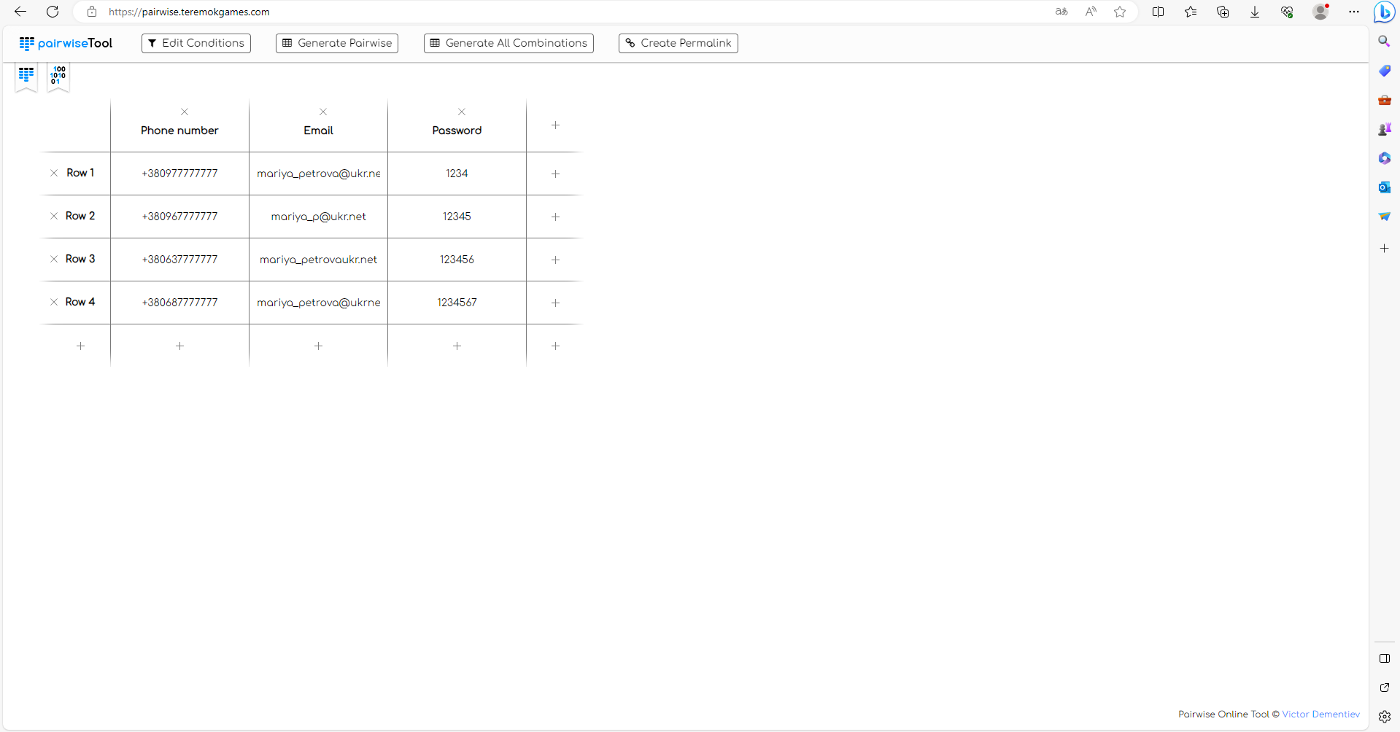

|  |  |  |  |
| --- | --- | --- | --- |
| 1 | 3,80978E+11 | mariya_petrova@ukr.net | 1234 |
| 2 | 3,80978E+11 | mariya_p@ukr.net | 12345 |
| 3 | 3,80978E+11 | mariya_petrovaukr.net | 123456 |
| 4 | 3,80978E+11 | mariya_petrova@ukrnet | 1234567 |
| 5 | 3,80968E+11 | mariya_p@ukr.net | 123456 |
| 6 | 3,80968E+11 | mariya_petrovaukr.net | 1234567 |
| 7 | 3,80968E+11 | mariya_petrova@ukrnet | 1234 |
| 8 | 3,80968E+11 | mariya_petrova@ukr.net | 12345 |
| 9 | 3,80638E+11 | mariya_petrovaukr.net | 1234 |
| 10 | 3,80638E+11 | mariya_petrova@ukrnet | 12345 |
| 11 | 3,80638E+11 | mariya_petrova@ukr.net | 123456 |
| 12 | 3,80638E+11 | mariya_p@ukr.net | 1234567 |
| 13 | 3,80688E+11 | mariya_petrova@ukrnet | 123456 |
| 14 | 3,80688E+11 | mariya_petrova@ukr.net | 1234567 |
| 15 | 3,80688E+11 | mariya_p@ukr.net | 1234 |
| 16 | 3,80688E+11 | mariya_petrovaukr.net | 12345 |

Вгадування помилок

**Вгадування помилок — це тільки невалідні варіанти**

**Summary:** Checking the operation of the search function by entering invalid data.

**Preconditions**

1. The <https://parfumcity.com.ua/ua> website is opened.

2. The user is not registered on this website.

|  |  |
| --- | --- |
| **Steps** | **Expected result** |
| Enter the invalid request in the search field (the special symbols: @, №, #,?, dots, etc.) | The request is entered in the search field |
| Click the «SEARCH» button | The message about the impossibility of finding the products for this request. is displayed on the main page. |